INDEX

# S.NO CONTENT PAGE NO.

|  |  |  |
| --- | --- | --- |
| 1 | ABSTRACT | 5-6 |
| 2 | INTRODUCTION | 7 |
| 3 | REQUIREMENT & ANALYSIS | 8-13 |
| 4 | ARCHITECTURE & DESIGN | 14 |
| 5 | IMPLEMENTATION | 16-21 |
| 6 | EXPERIMENT RESULTS & ANALYSIS | 22-24 |
| 7 | CONCLUSION | 25 |
| 8 | BIBLIOGRAPHY | 25 |

**ABSTRACT**

The network design is a major part of the infrastructure of any institution. Communication is a major factor that plays a vital role in ensuring that all the levels of staff are able to carry it out effectively in order to achieve. A good network design will be more robust and allow for better performance overall by working quickly and efficiently and providing the best platform.

The main aim of this project is to design a network setup which meets the requirements of a university allowing effective exchange of information between the various departments.

A LAN includes all the user devices, servers, switches, routers, cables, and wireless access points in one location. It includes all devices in the same broadcast domain. A broadcast domain includes the set of all LAN-connected devices, so that when any of the devices sends a broadcast frame, all the other devices get a copy of the frame. So, from one perspective, a LAN and a broadcast domain as being basically the same thing. Without VLANs, a switch considers all its interfaces to be in the same broadcast domain. That is, forgone switch, when a broadcast frame entered one switch port, the switch forwarded that broadcast frame out all other ports.

With that logic, to create two different LAN broadcast domains, needs two different Ethernet LAN switches.

With support for VLANs, a single switch can accomplish the same goals of the design to create two broadcast domains—with a single switch. With VLANs, a switch can configure some interfaces into one broadcast domain and some into another, creating multiple broadcast domains. These individual broadcast domains created by the switch are called virtual LANs (VLAN).

Designing campus LANs to use more VLANs, each with a smaller number of devices, often helps improve the LAN in many ways. For example, a broadcast sent by one host in a VLAN will be received and processed by all the other hosts in the VLAN—but not by hosts in a different VLAN. Limiting the number of hosts that receive a single broadcast frame reduces the number of hosts that waste effort processing unneeded broadcasts. It also reduces security risks, because fewer hosts see frames sent by any one host.

The following list summarizes the most common reasons for choosing to create smaller broadcast domains (VLANs):

* To reduce CPU overhead on each device by reducing the number of devices that receive each broadcast frame.
* To reduce security risks by reducing the number of hosts that receive copies of frames that the switches flood (broadcasts, multicasts, and unknown unicasts)
* To improve security for hosts that send sensitive data by keeping those hosts on a separate VLAN
* To create more flexible designs that group users by department, or by groups that work together, instead of by physical location
* To solve problems more quickly, because the failure domain for many problems is the same set of devices as those in the same broadcast domain

# Introduction

The task is to create a wireless network proposal has to be prepared for setting up a wireless VLAN based infrastructure at a campus. The campus has 3 departments, management, research and finance.

Each department has approximately 30 users. ADSL internet connection is available in the campus, which needs to be shared by the all the users in the different departments. Wireless access to the network should be available using access points installed at strategic locations.

Users should also be able to access the network through computers using LAN connectivity. Files servers should be setup on the network for users in the departments to share and transfer files. Guest users should be able to connect to the internet through the wireless access points, without any authentication. Users in each department should have a common password, which should be used for gaining access to the network through the wireless access points. The guest users should not have access to the file server installed on the network. Dynamic IP addressing system should be available from a single DHCP server to allocate IP address to all departments users and guests. Users should be able to connect to the appropriate departments, highlighted through appropriate names on the access point. Appropriate equipment for internet sharing should be made available.

Key points to mention from above:

→ VLAN

→ 30 user’s subnet each

→ Wireless

→ Access point

→ Files(ftp)

→ DHCP

→ Website

# REQUIREMENT & ANALYSIS

## Hardware Requirements

Processor : 2.4 GHz Clock Speed RAM : 1 GB

Hard Disk : 500 MB (Minimum free space)

## Software Requirements

Operating System : Windows 7 Platform : Java

Back End : MySql

Special Tools : Opencv, Xuggle Server : Apache Tomcat

## Serial: Modules:

* + - 1. Hosts

## Routers

* + - 1. Switch

## Server

* + - 1. Cables

## ADSL Modem

* + - 1. Cloud

#### Cisco Packet Tracer (V8.0.0)-

Cisco Packet Tracer as the name suggests, is a tool built by Cisco. This tool provides a network simulation to practice simple and complex networks. The main purpose of Cisco Packet Tracer is to help students learn the principles of networking with hands-on

experience as well as develop Cisco technology specific skills. Since the protocols are implemented in software only method, this tool cannot replace the hardware Routers or Switches. Interestingly, this tool does not only include Cisco products but also many more networking devices.

#### 

#### MODULES DESCRIPTION:

**Routers:**

A router is a networking device that forwards data packets between computer networks. Routers perform the traffic directing functions on the Internet.

Data sent through the internet, such as a web page or email, is in the form of data packets. A packet is typically forwarded from one router to another router through the networks that constitute an internetwork (e.g. the Internet) until it reaches its destination node.

#### Switches:

A network switch (also called switching hub, bridging hub, and, by the IEEE, 1 MAC bridge) is networking hardware that connects devices on a computer network by using packet switching to receive and forward data to the destination device.A network switch is a multiport nework bridge that uses MAC addresses

to forward data at the data link layer (layer 2) of the OSI model often see them used in home networks or wherever a few more ports are needed, such as at your desk, in a lab, or in a conference room.

#### DSL Modem

This converts digital signals into analogue signals that are suitable for sending over a telephone line. It is usually built into the Internet/broadband router and not normally purchased as a separate component.

#### DSL/Broadband Filter

Used to filter out DSL signals from telephone signals so that you can access the internet and use the telephone simultaneously.

#### Requirement analysis of routers and switches

For this network we’ll be needing

→ Router (1) - Cisco RV016 16-port 10/100 VPN Router - Multi WAN

→ Layer 2 switch (7) - Cisco SG350-10 Managed Switch

→ Multi-layer switch (1) - Cisco Nexus 3164Q - switch - 64 ports

**Router configuration guidelines**

**Access CLI prompt of router**

Cisco IOS supports various command modes, among those following are the main command modes.

→ User EXEC Mode

→ Privileged EXEC Mode

→ Global Configuration Mode

→ Interface Configuration Mode

→ Sub Interface Configuration Mode

→ Setup Mode

→ ROM Monitor Mode

**Following table lists essential commands to navigate between different IOS modes.**

|  |  |  |  |
| --- | --- | --- | --- |
| Mode | Prompt | Command to enter | Command to exit |
| User EXEC | Router > | Default mode after booting.Login with password, if configured. | Use exit command |
| Privileg ed EXEC | Router # | Use enable command from userexec mode | Use exit command |

|  |  |  |  |
| --- | --- | --- | --- |
| Interface Configuration | Router(config-if)# | Use interface type *number*command from global configuration  mode | Use exit command to return in global configuration mode |
| Sub-Interface Configuration | Router(config-subif) | Use interface type *sub interfacenumber* command from global configuration mode or interfaceconfigure mode | Use exit to return previous mode. Use end command toreturn in privileged exec mode. |
| Setup | Parameter[Paramet ervalue]: | Router will automatically insertin this mode if running configuration is not present | Press CTRL+C to abort. Type yes to save configuration, or no to exitwithout saving when askedin the end  of setup. |
| ROMMON | ROMMON > | Enter reload command from privileged exec mode. Press CTRL + C key combination during the first 60 seconds of  booting process | Use exit command. |
| Global Configurations | Router(config)# | Use configures terminal command from privileged exec mode | Use exit command |

|  |  |  |  |
| --- | --- | --- | --- |
| vlan | vlan> | To access VLAN database configuration mode, enter thevlan database privileged EXEC command. Then enter the vlan command with a newVLAN ID to create a VLAN, orenter an  existing VLAN ID to modify the VLAN. | Use exit command |

→ IOS commands are not case sensitive; you can enter them in uppercase, lowercase, or mixed case.

→ Password is case sensitive. Make sure you type it in correct case.

→ In any mode, you can obtain a list of commands available on that mode by entering a question mark (?).

→ Standard order of accessing mode is

→ User Exec mode => Privileged Exec mode => Global Configuration mode

=> Interface Configuration mode => Sub Interface Configuration mode

→ Router will enter in setup mode only if it fails to load a valid running configuration.

→ Router will enter in ROMMON mode only if it fails to load a valid IOS image file

**ARCHITECTURE & DESIGN**

* 1. Network topology diagram

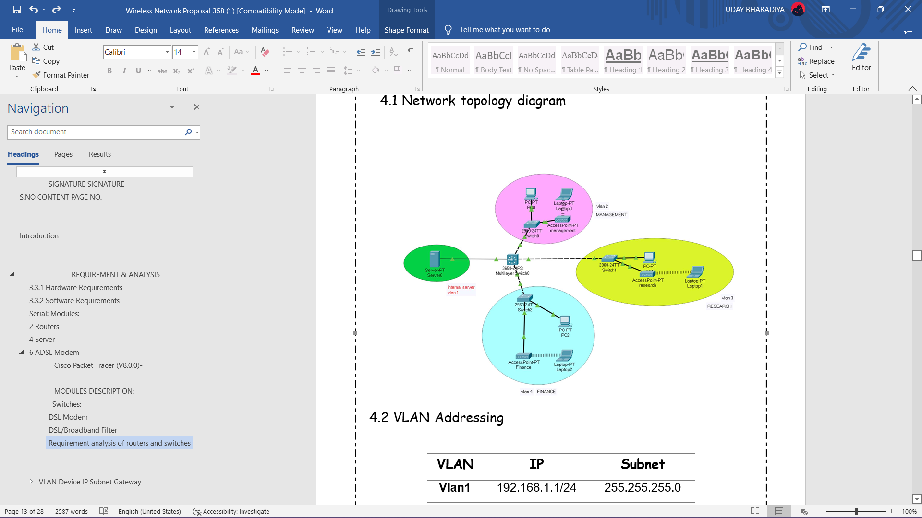

* 1. VLAN Addressing

|  |  |  |
| --- | --- | --- |
| **VLAN** | **IP** | **Subnet** |
| **Vlan1** | 192.168.1.1/24 | 255.255.255.0 |
| **Vlan2** | 192.168.2.1/27 | 255.255.255.0 |
| **Vlan3** | 192.168.3.1/27 | 255.255.255.0 |
| **Vlan4** | 192.168.4.1/27 | 255.255.255.0 |

### VLAN Device IP Subnet Gateway

##### PC0 192.168.2.2 255.255.255.0 192.168.2.1

**Vlan1**

##### LAPTOP 0 192.168.2.3 255.255.255.0 192.168.2.1

PC1 192.168.3.2 255.255.255.0 192.168.3.1

**Vlan2**

LAPTOP 1 192.168.3.3 255.255.255.0 192.168.3.1

|  |  |  |  |  |
| --- | --- | --- | --- | --- |
| **Vlan3** | PC2 | 192.168.4.3 | 255.255.255.0 | 192.168.4.1 |
|  | LAPTOP 2 | 192.168.4.2 | 255.255.255.0 | 192.168.4.1 |
| **Vlan4** | SERVER-PT | 192.168.1.2 | 255.255.255.0 | 192.168.1.1 |



### IMPLEMENTATION

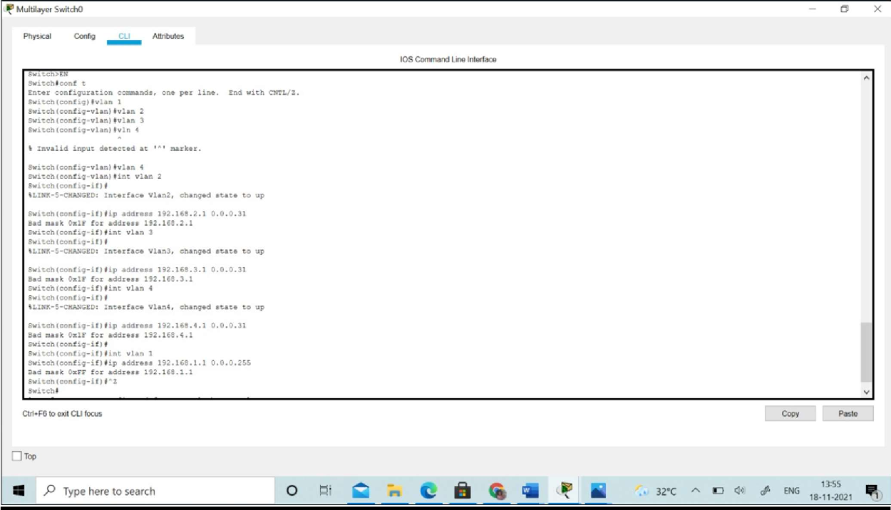

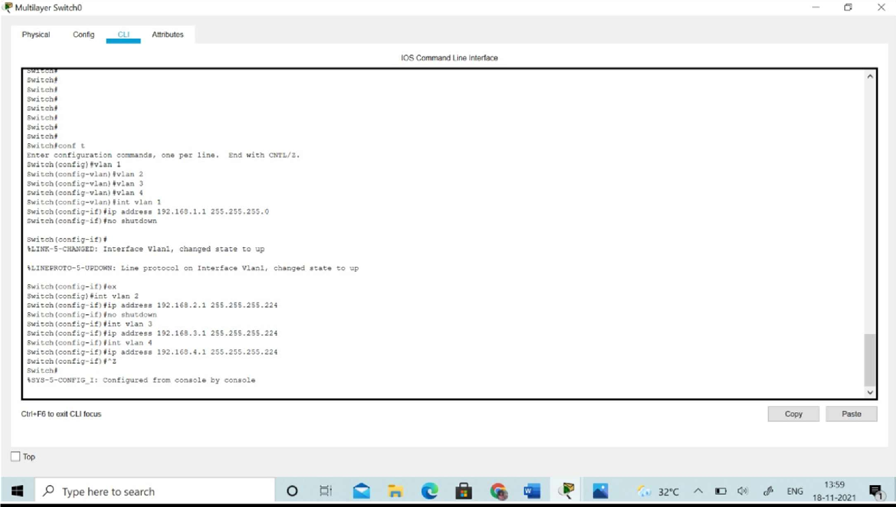

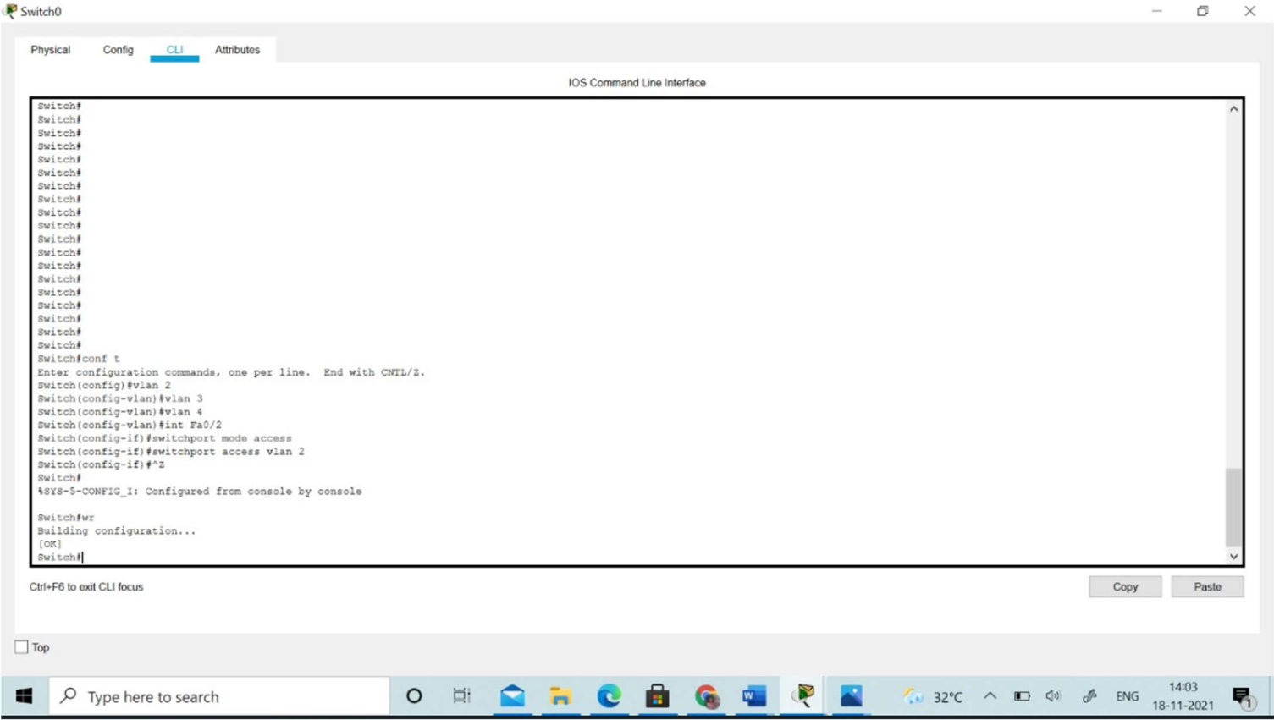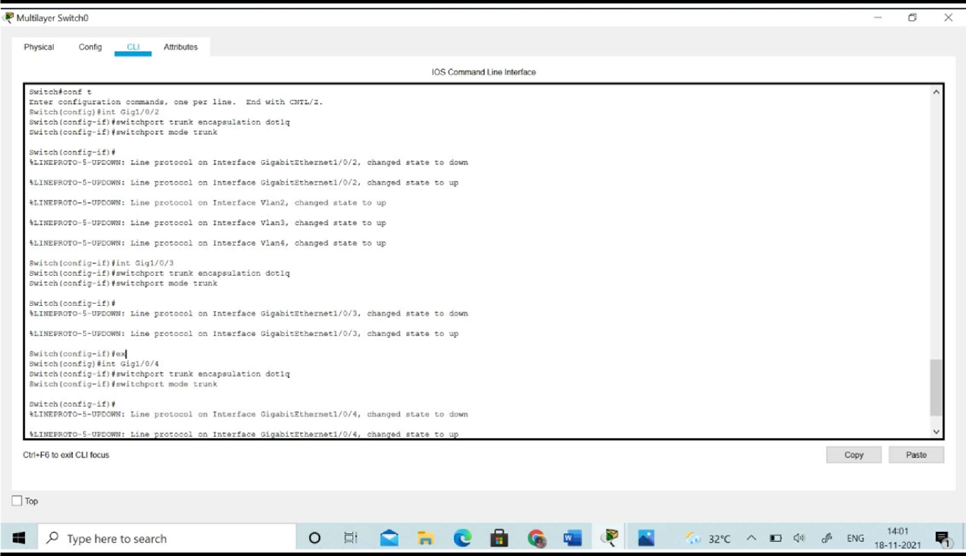

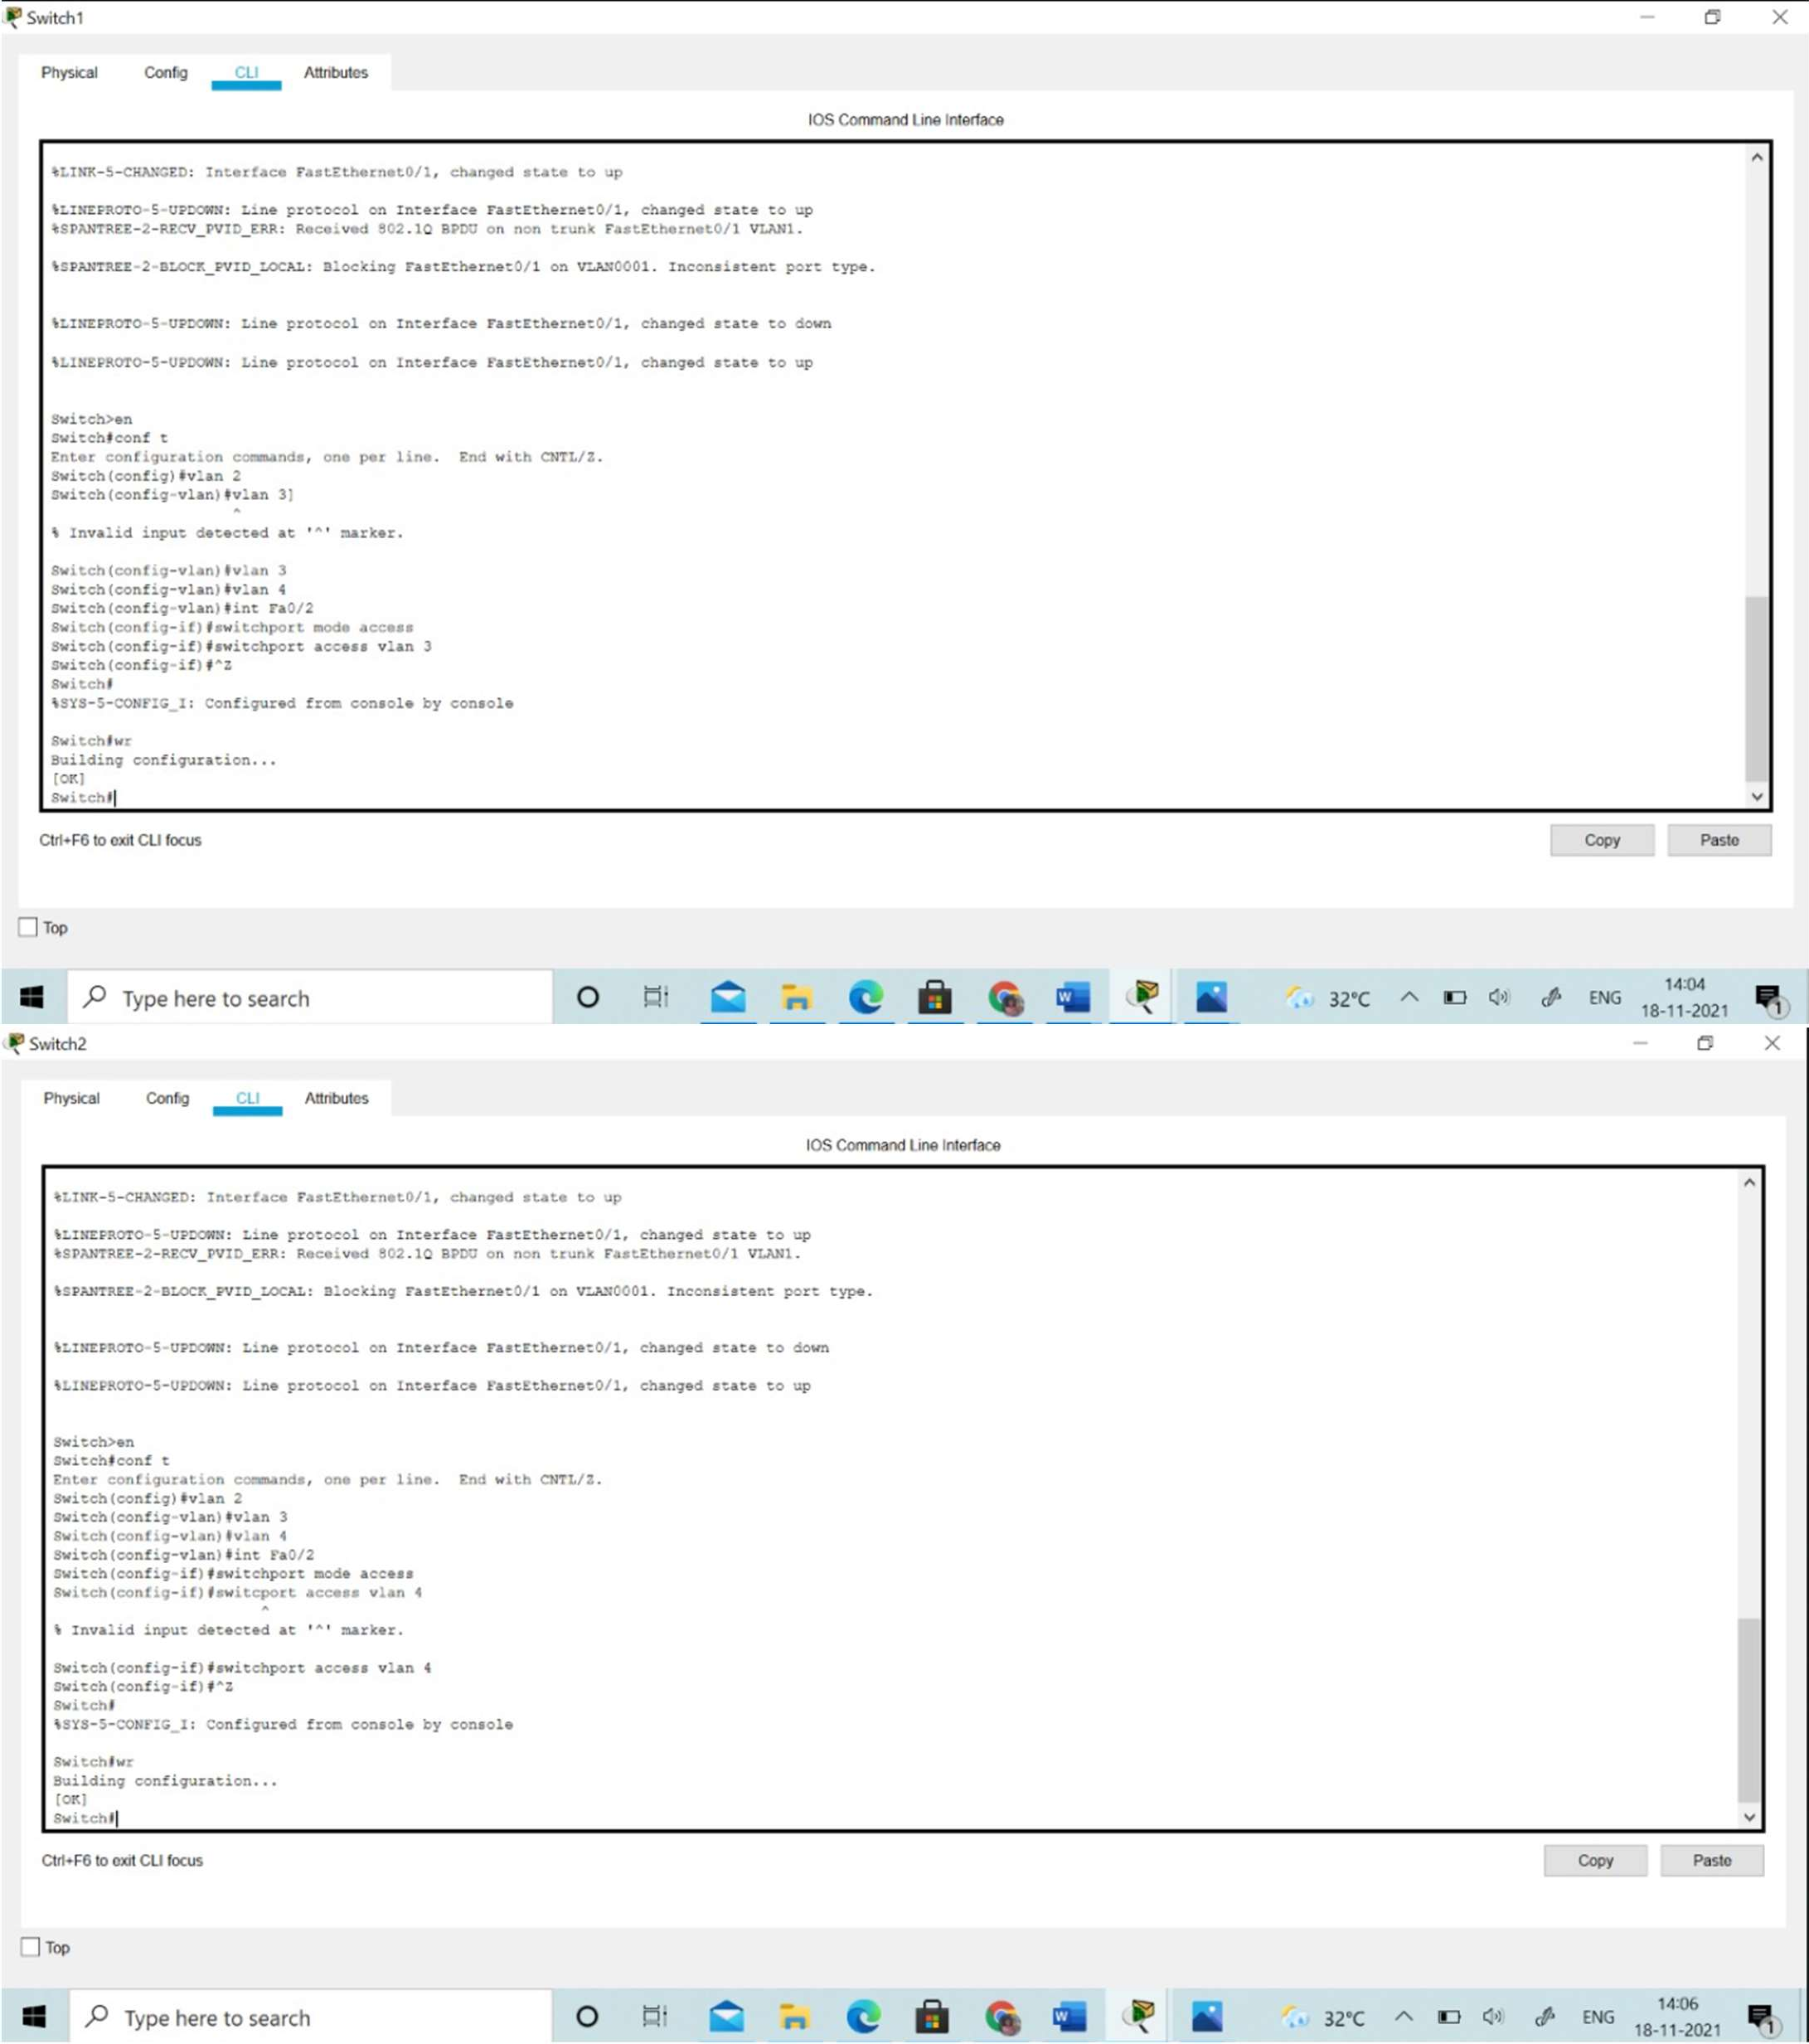



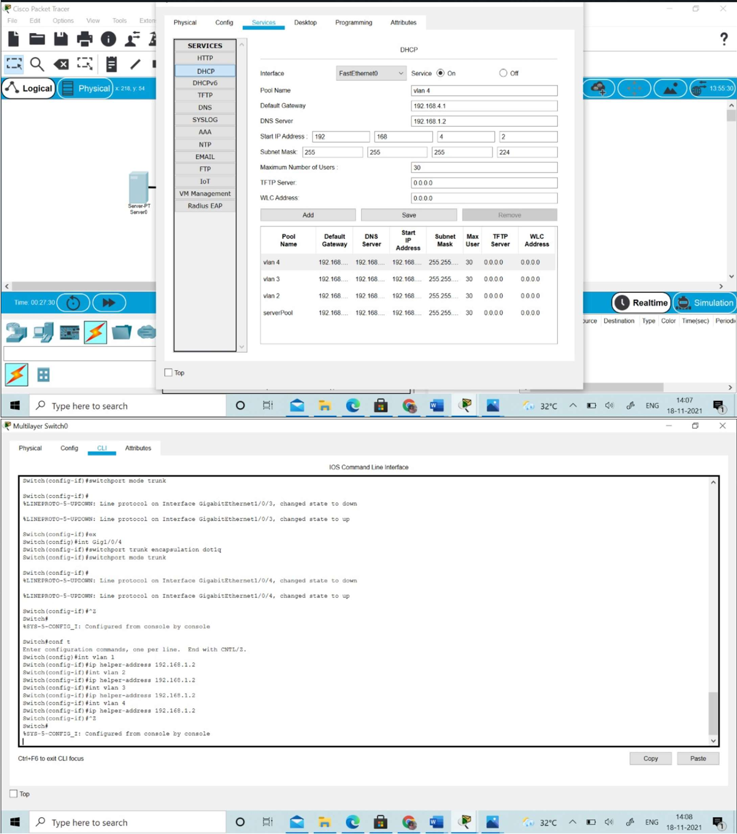



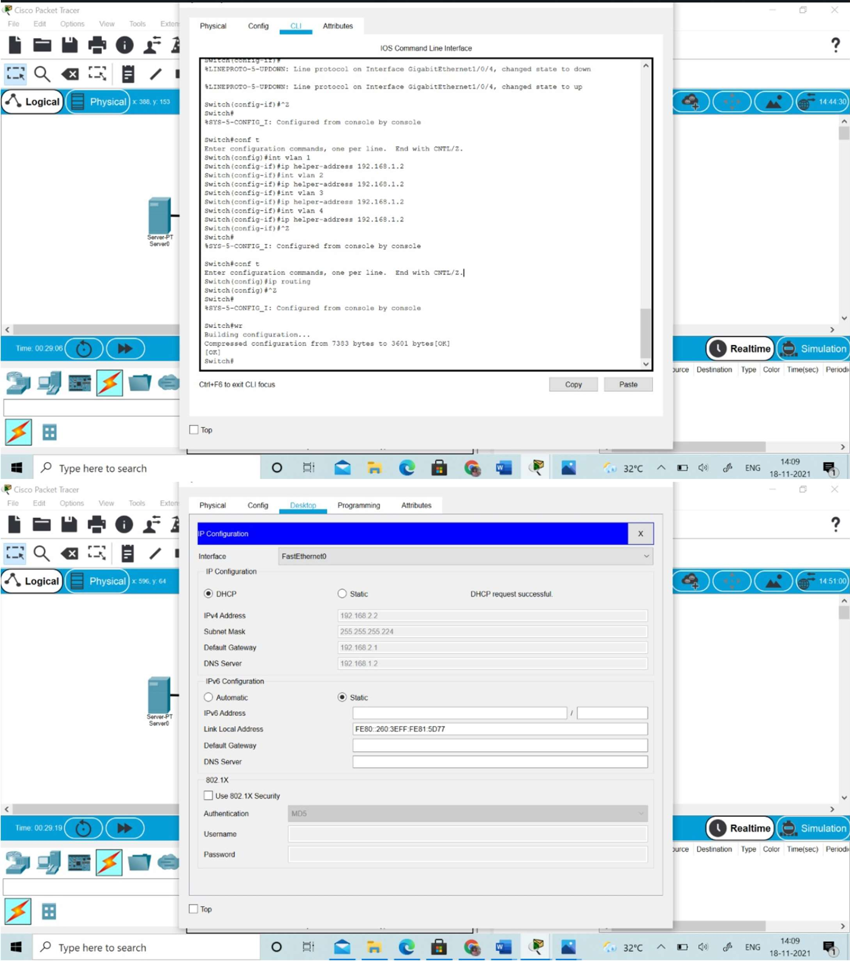



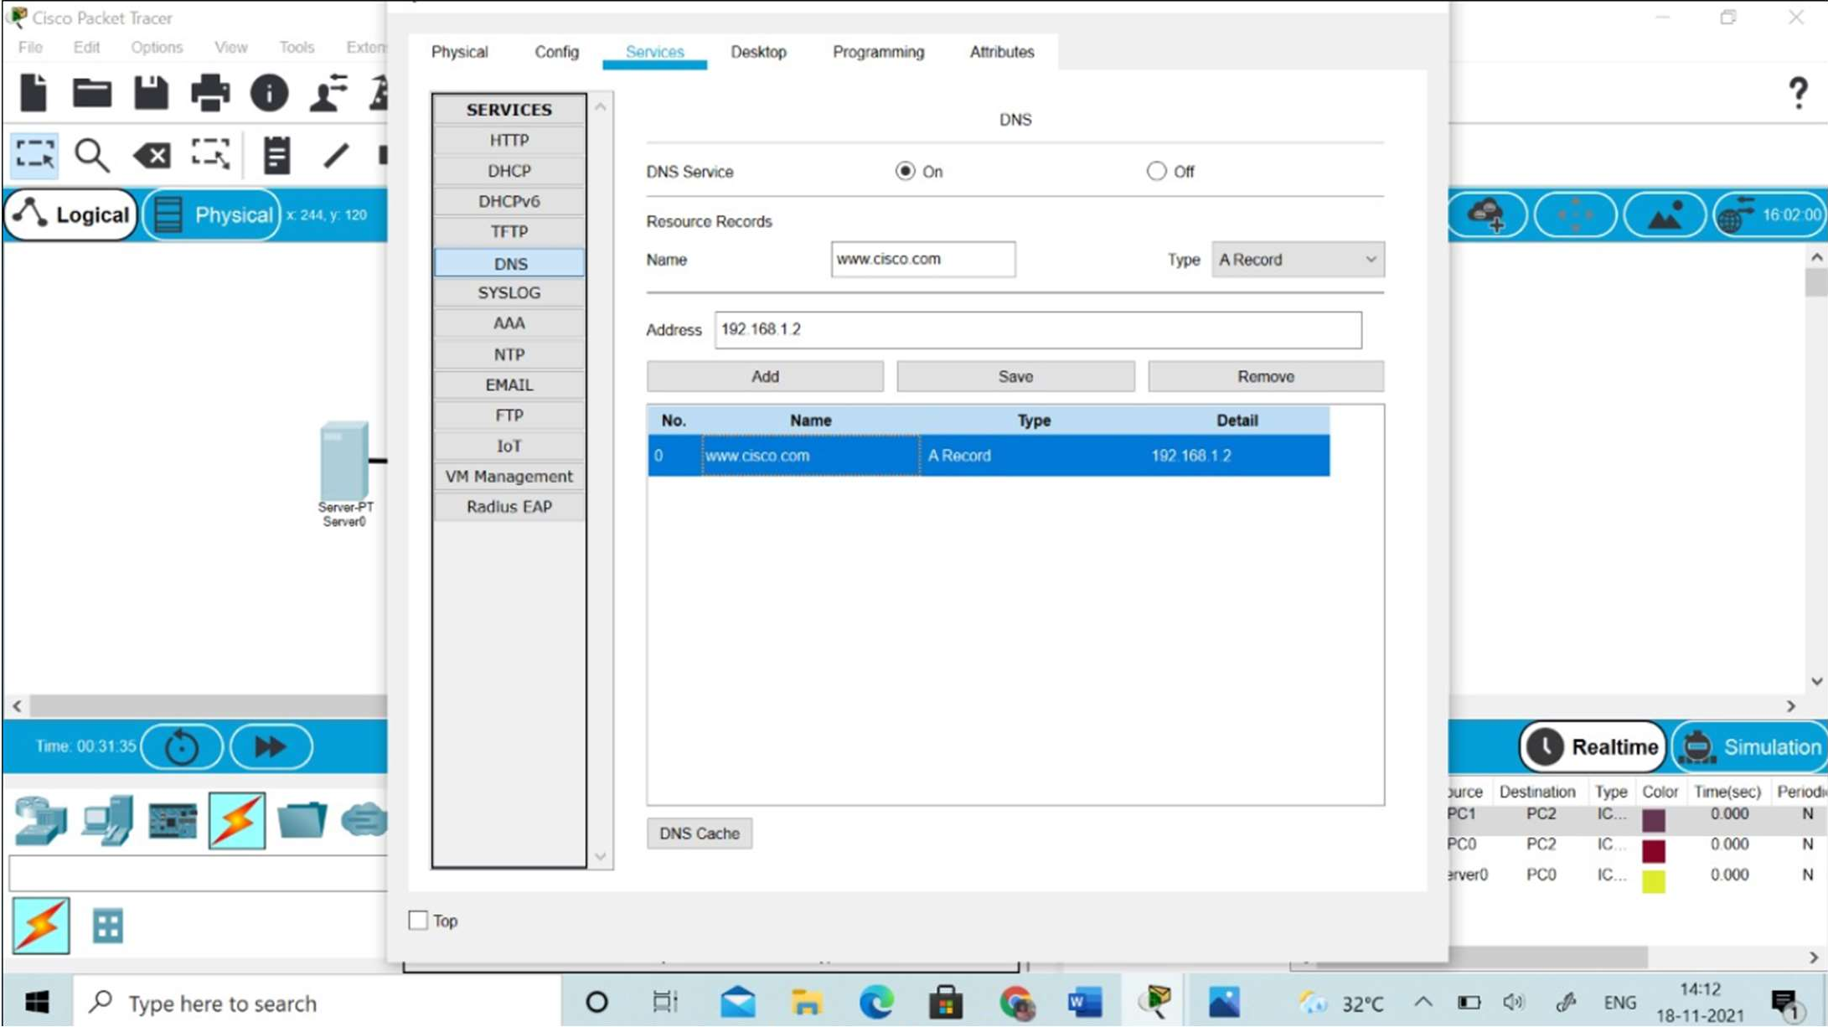



**RESULTS:**

### EXPERIMENT RESULTS & ANALYSIS

As the college internet is accessed in each of computer on web browser it is checked as follows



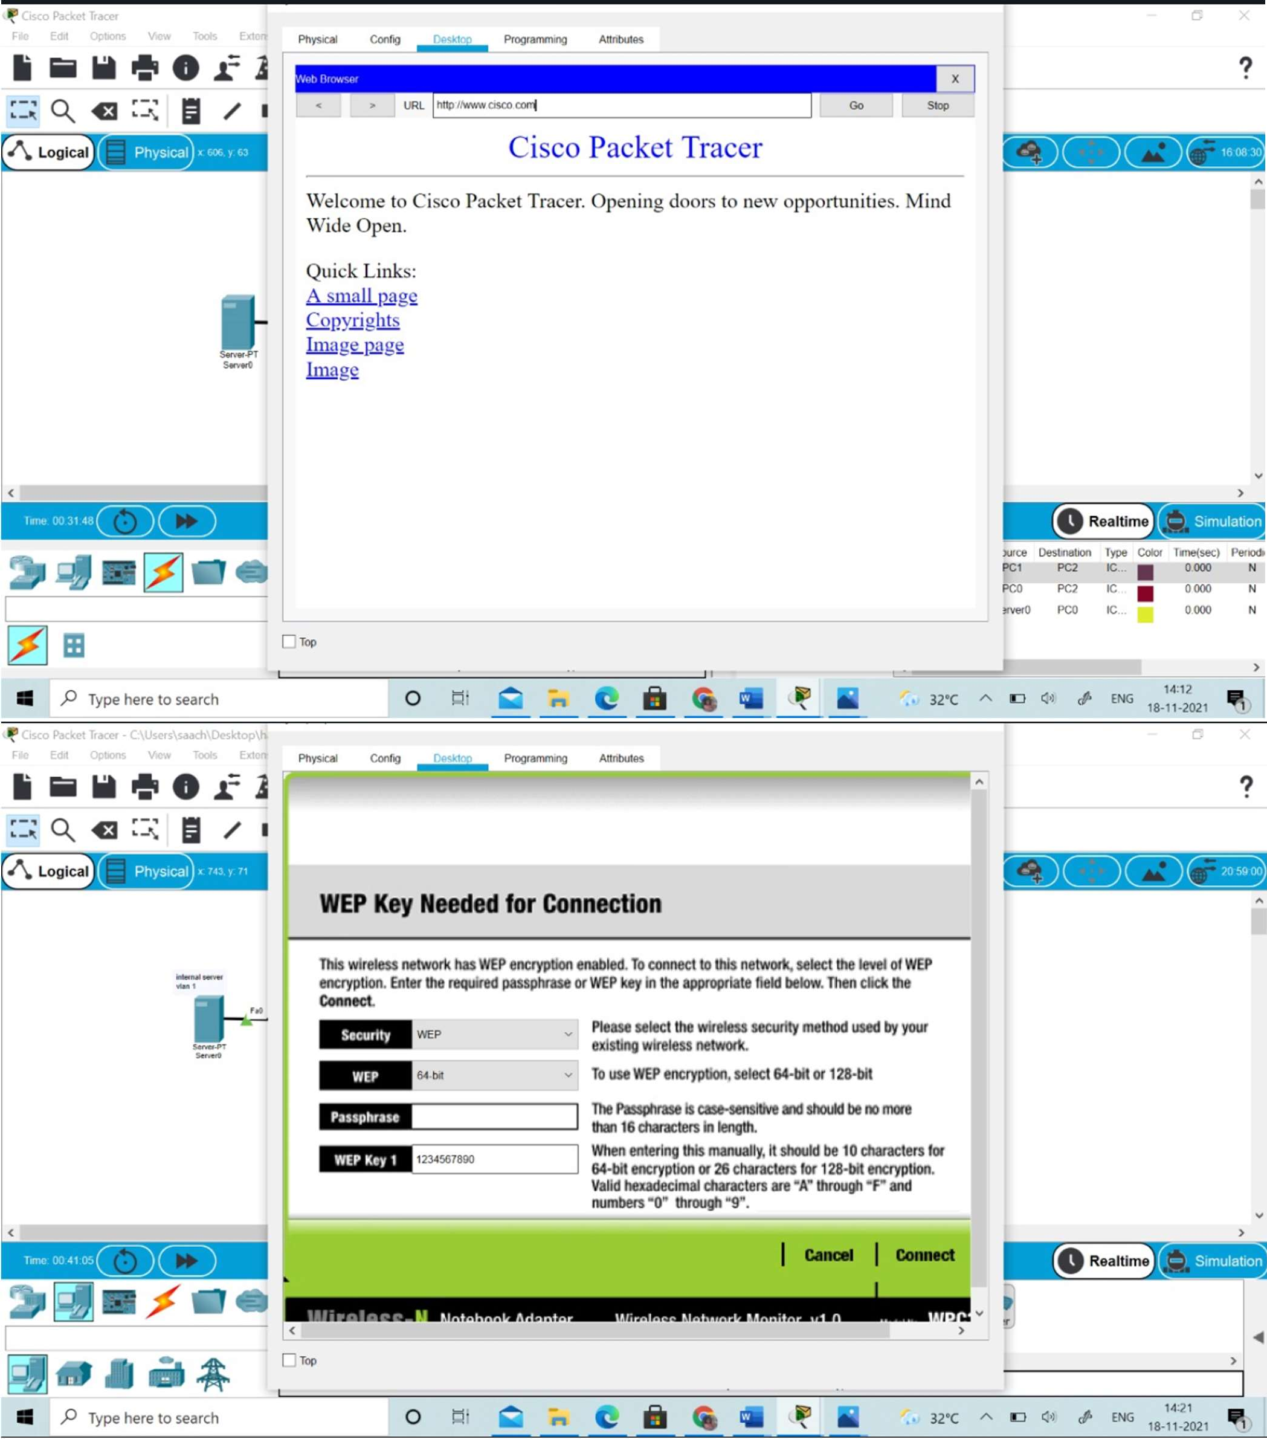

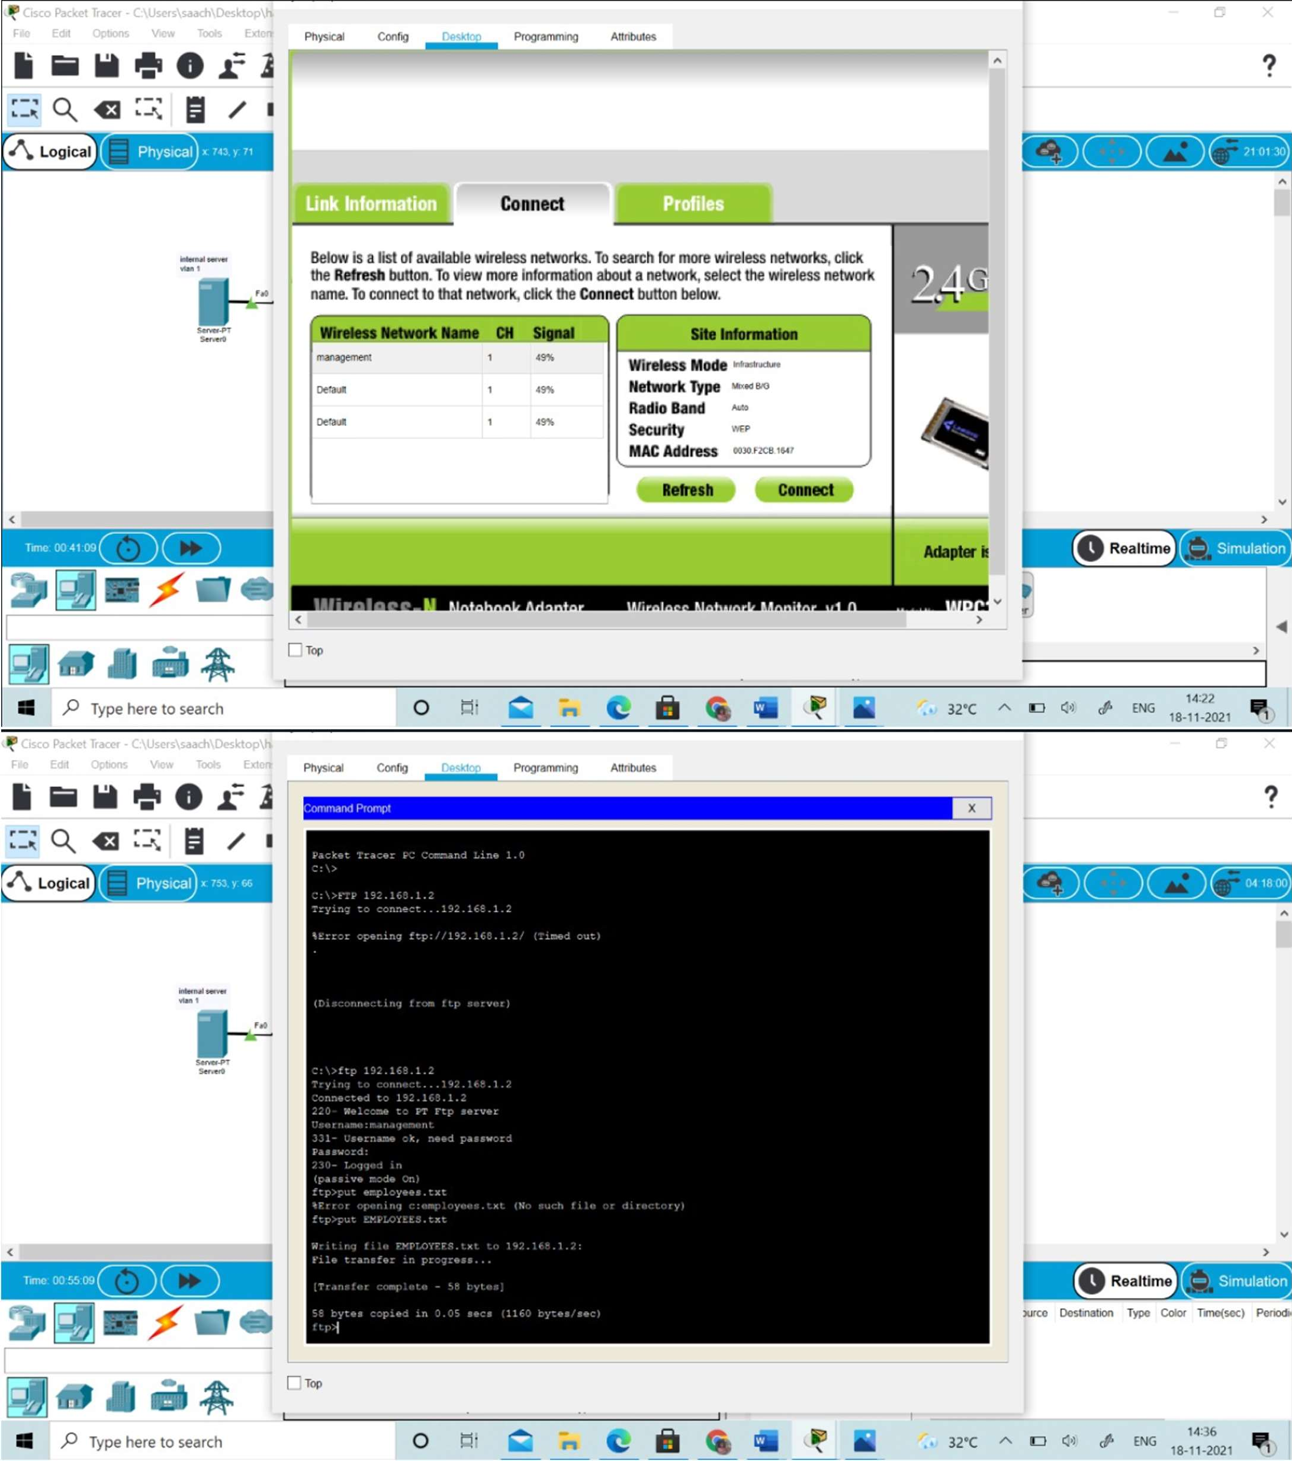



**USES OF VLAN:**

→ VLANs enable logical grouping of end-stations that are physically dispersed on a network.

→ When users on a VLAN move to a new physical location but continue to perform the same job function, the end-stations of those users do not need to be reconfigured. Similarly, if users change their job functions, they need not physically move: changing the VLAN membership of the end-stations to that of the new team makes the users' end- stations local to the resources of the new team.

→ VLANs reduce the need to have routers deployed on a network to contain broadcast traffic.

→ Flooding of a packet is limited to the switch ports that belong to a VLAN.

→ Confinement of broadcast domains on a network significantly reduces traffic.

→ By confining the broadcast domains, end-stations on a VLAN are prevented from listening to or receiving broadcasts not intended for them. Moreover, if a router is not connected between the VLANs, the end-stations of a VLAN cannot communicate with the end-stations of the other VLANs.

**USES OF NAT:**

→ Reuse of Private IP addresses

→ Enhancing security for private networks by keeping internal addressing private from the external network

→ Connecting a large number of hosts to the global Internet using a smaller number of public (external) IP address, thereby conserving IP address space.

**USES OF ACL:**

→ Improve network performance.

→ Provides security as administrator can configure the access list according to the needs and deny the unwanted packets from entering the network.

→ Provides control over the traffic as it can permit or deny according to the need of network.

**FUTURE SCOPE OF PROJECT:**

This project can be further used in many processes like increasing more and more algorithms and bringing in more simulation techniques

### Threats

Since the user in each department has a common password, there is a possibility of breaching the key.

If the key gets cracked by the hackers, they will have access to all the departments and their information.

And, now talking about the guest, the guest gets connected without any authentication.

Here a problem arises that people outside the campus have access since there’s no authentication.

There is a common password.

SYSTEM REQUIREMENTS

* Kali linux
* Windows 7 (because windows 10 has more features which will not let us perform our thesis)
* AR9271 wireless adapter
* Two computers/laptops (one with virtual box and one with cisco packet tracer)

STEPS

Complete the installation of Kali linux and other necessary software applications.

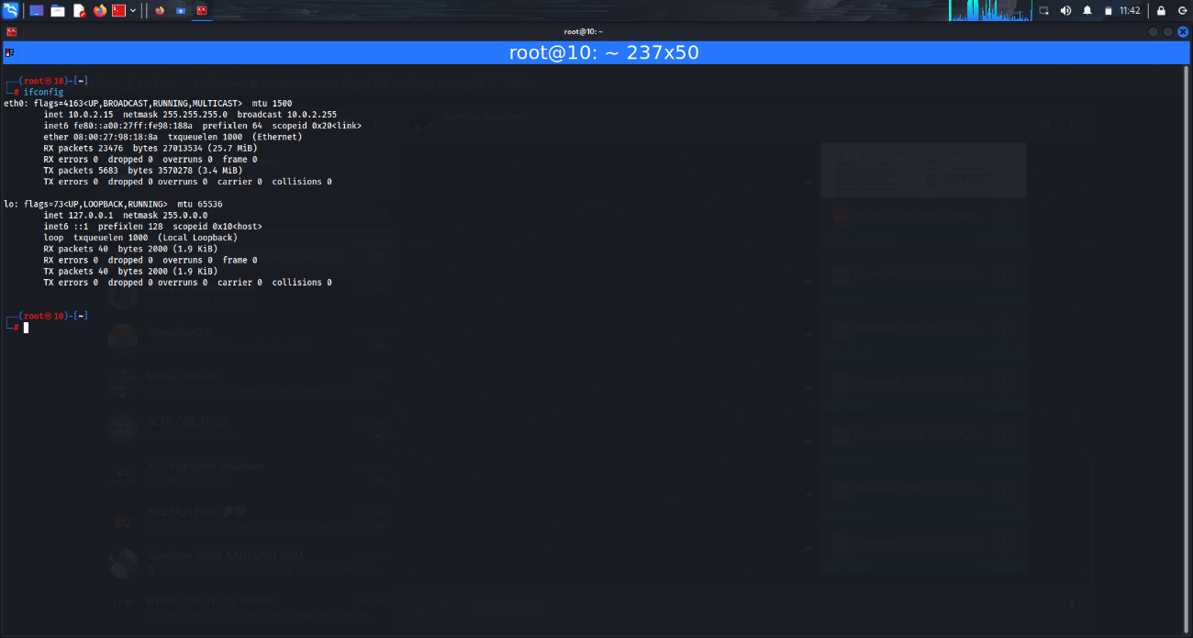

Plug in the wireless adapter

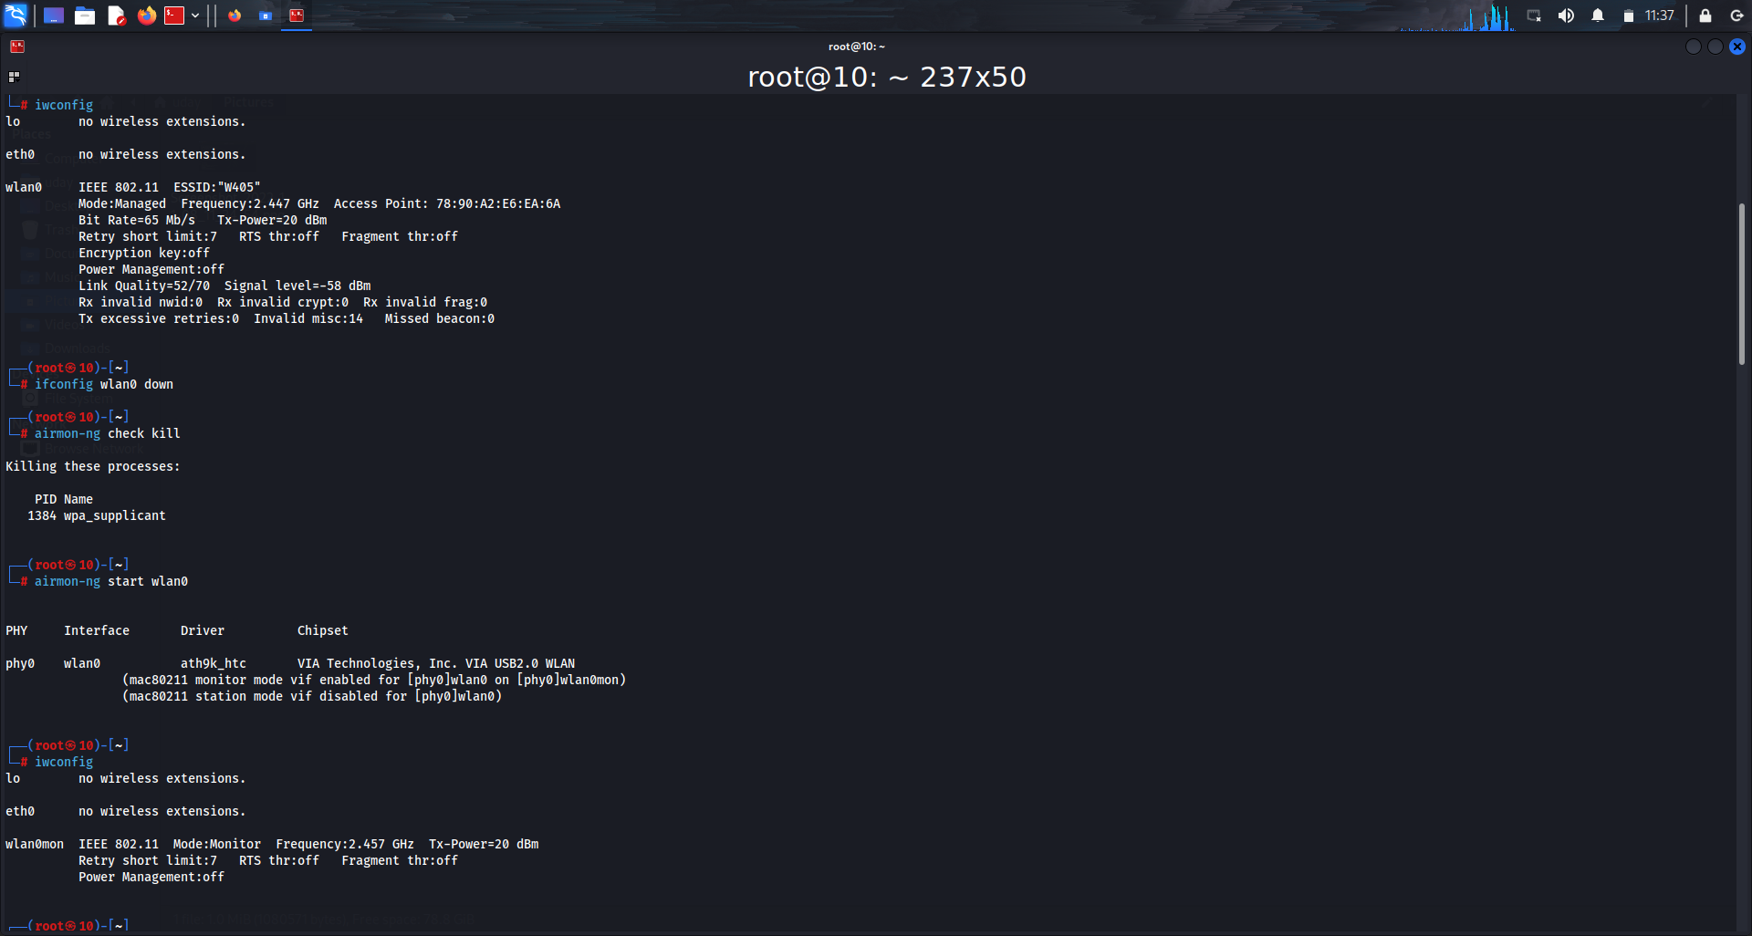

AR9271 is used to capture packets that are sent in the air from the source to targeted destination

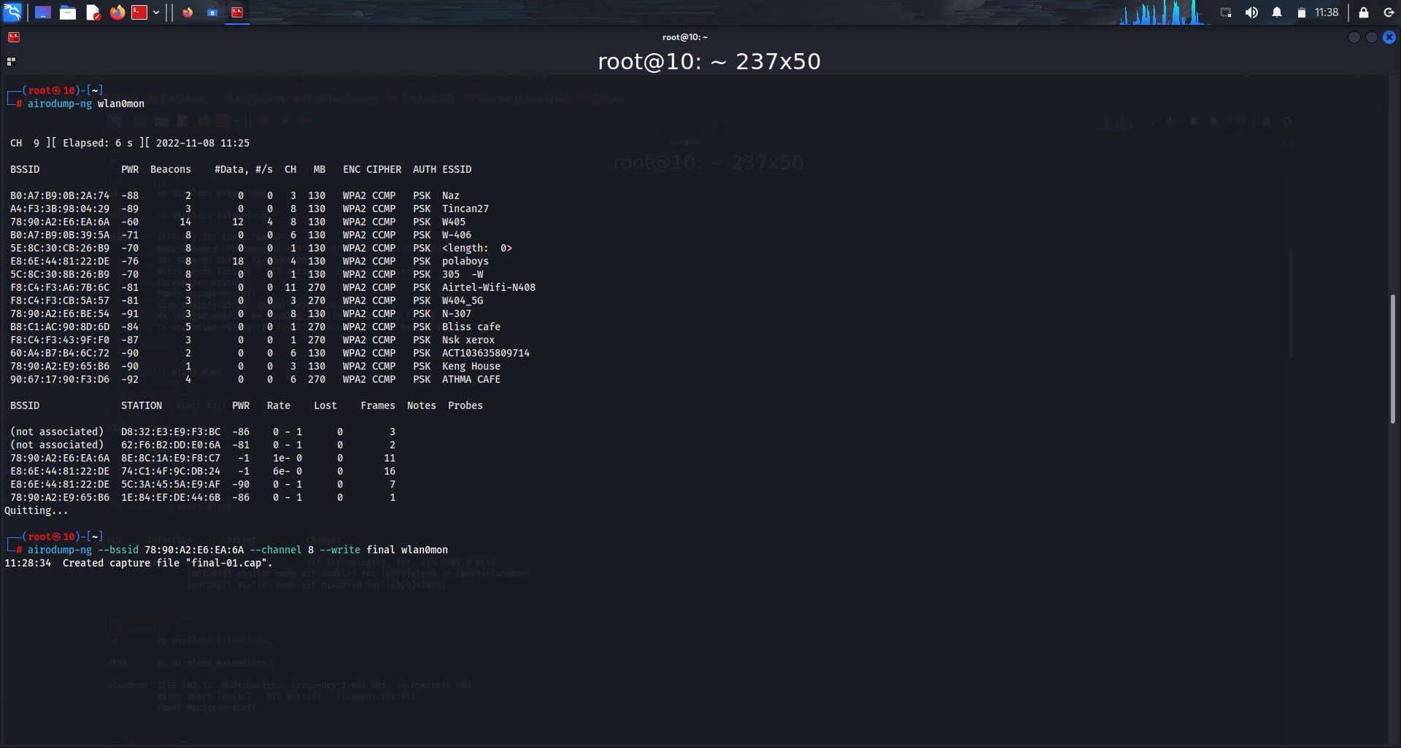

1. Then we perform authentication attack where we disconnect a client from any network. This works on encrypted network(WEP/WPA/WPA2). This step will disconnect them from the wifi they are connected to.

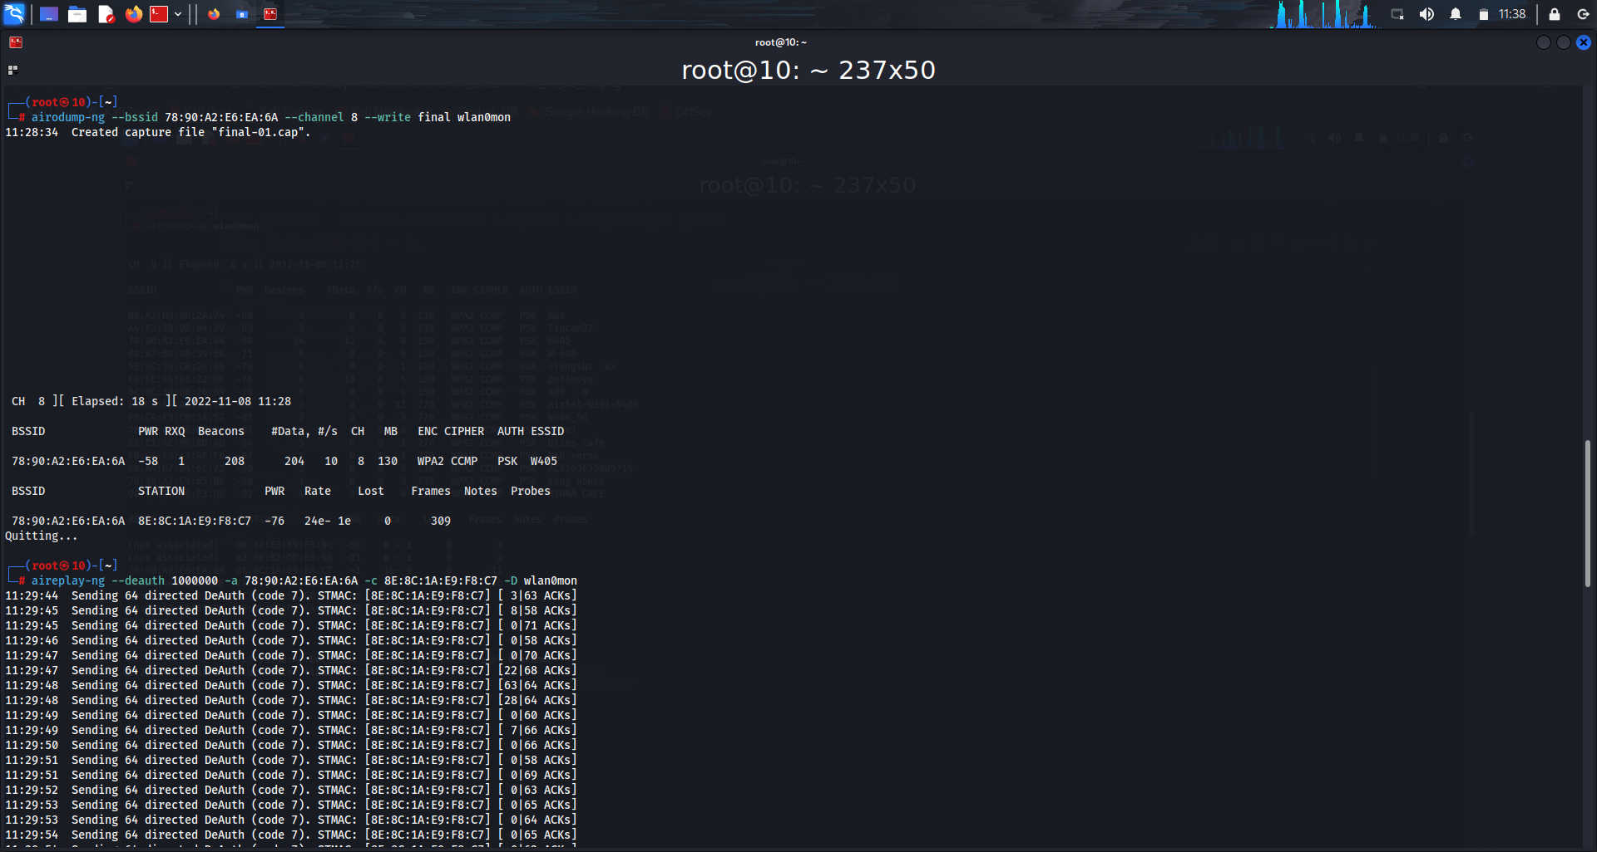

1. Once they’re disconnected, the hackers get the access point and they establish a front door for themselves. Now, the hackers often create a fake network with the same key and the client unknowingly will give the key to the hackers through which they’ll have access to the data.
2. We’ll need to check the encryption now. In this project we’re showing how easy it is to hack WEP encryption.

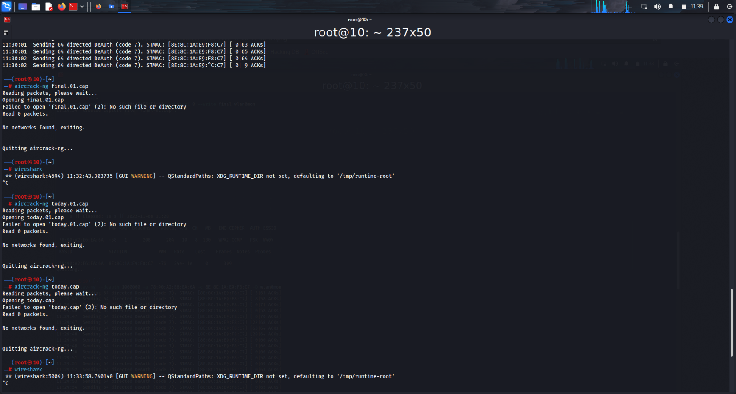

1. To crack WEP encryption, we need to capture a large no. of packets, the analyze the IVs and crack the key
2. Now that we got the key, we’ll perform “fake authentication attack”. (MAC address of wireless adapter changes after enabling monitor mode, so we need to check the MAC address. Split the terminal horizontally and type “ifconfig” and copy the first 6 digits of the MAC address)
3. ARP request replay attack.

Since WEP is weak, we use WPA/WPA2 encryption. It is much more secure and each packet is secured using a unique temporary key. The packets contains no useful information. We can use the WPS feature along to make it more efficient. This only works if the router is configured not to use PBC (push button configuration)

Handshake packets are the only ones that can aid with cracking process.

### Conclusion

With the growth of Information Technology in every sector and the explosion of medical IOT devices, the design of a network of any hospital has become very essential factor.

The hospitals need to have a reliable, secure and scalable network design in order to keep the patient’s information, doctor's research work safe, convenient communication between various departments, etc. as well as keep it ready for any new IOT medical equipment’s that may be introduced in the future.

The hierarchical model of networking best suits our needs along with providing additional features like easy maintenance, high security, simplified troubleshooting and effective performance.

### Reference

[1]-The University Network - A New Approach Towards Networking ZeeshanAhmed Siddique

[2]-University Network Infrastructure: a Modern Look Into the Network Backbonewith Real Time Visibility Homan Mike Hirad

[3]-Ethical Hacking course by Udemy